Make sure to do the following in the “Minesweeper” directory, not the “src” directory!!

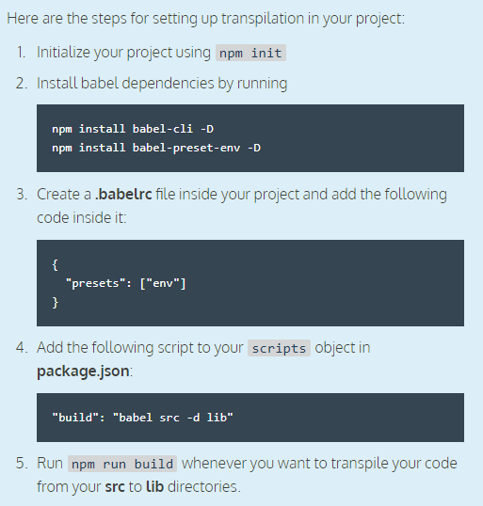

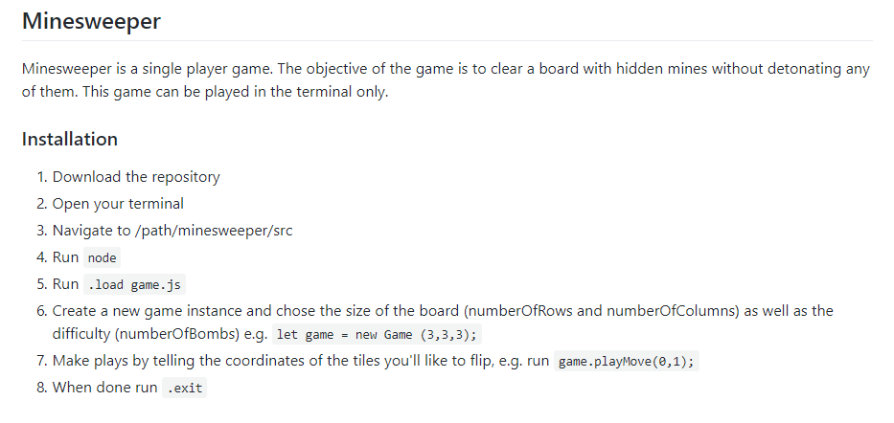

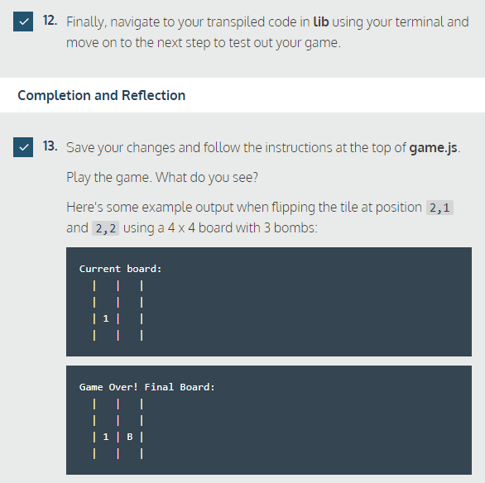

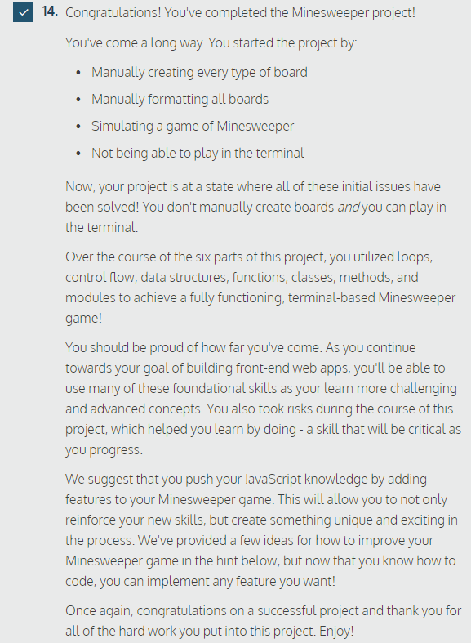

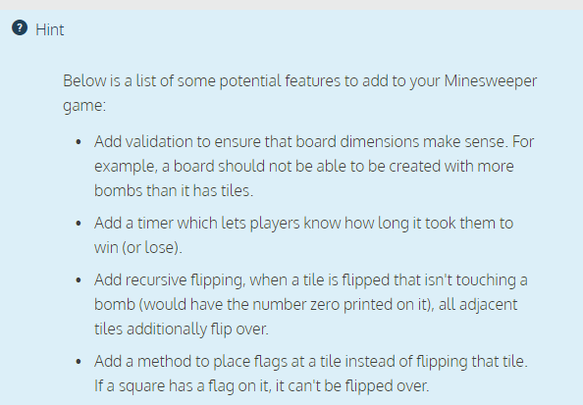

* Go to lib directory
* node (enter)
* .load game.js (enter)
* let game = new Game (3,3,3); (enter)
* game.playMove(0,1); (enter)
* repeat until the game is over
* When the game is over, to play another game:
* .exit (enter)
* Node (enter)
* …..

My first game!

|

|

|

|

|

`’

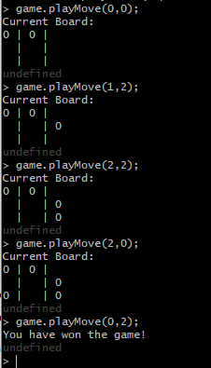

I don’t seem to have any bombs…

I get this message when trying to start a new game after one has finished:

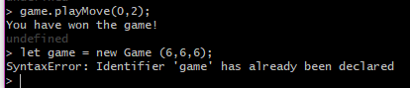

First game with bombs LOL

